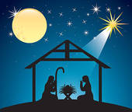

Thank You!

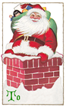
I want to thank everyone that made Breakfast with Santa such a successful event. I am filled with gratitude towards all of the parents and teachers that have made it possible, for all your donations, for you valuable time, for the effort you all put to into this event to make it so special for our students. It was heart-warming to see so many families and teachers come together to support this event and to see so many of our students having a great time.
With gratitude,
Mrs. Giordano

During this Advent Season may your hearts be filled with joy, peace, hope and love.

