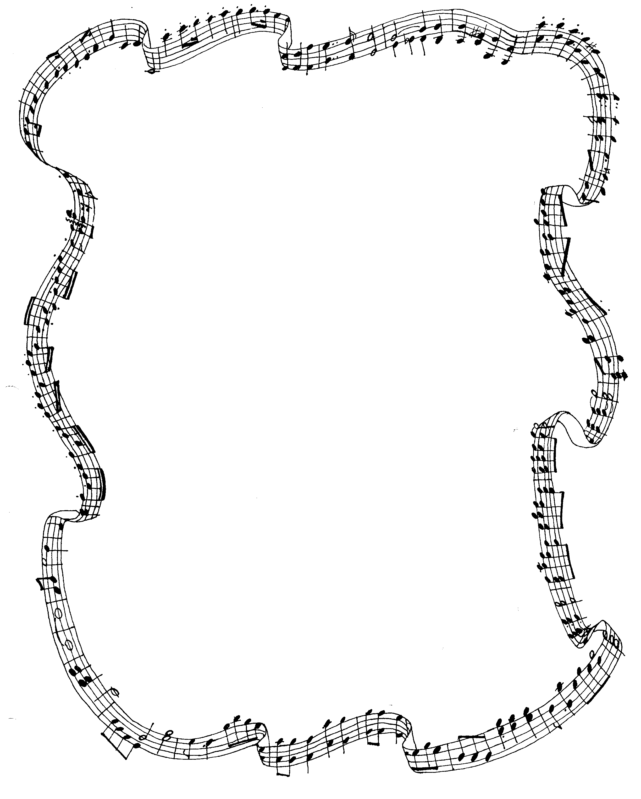

Calling all singers! It’s time to join…

CHOIR CLUB!

Choir Club will meet Mondays from 2:30-3:30PM

Start date: October 1st

Open to all students in 3rd, 4th, 5th, 6th, 7th & 8th grade

Everybody has a voice. If you’d like to learn more about yours,
this club is for you.

We will focus on folk-style hymns for Mass & music for school events.
(And we may write a few songs of our own!)

All students will learn tried and true performance techniques.
Choir Club will meet in the cafeteria.
Rehearsal will be in the room #8.
Hope to see you there!
Ms. A.

Sign up & start date: Monday, October 1^{st!}

