SJS Cornhole Tournament
March 29, 2019
Doors open at 6:30
Tournament starts at 7:00
$20.00 Per Team
3 Divisions: (4 members per team)
Students from K-2 (only 1 adult per team)
Students from 3-5 (only 1 adult per team)
Students from 6-8 (all team members must be students and the team must have an “adult manager”)
**Entry forms can be found in the Virtual Folder**
Space is limited... forms with the entrance fee (checks made out to SJS) must be submitted to Mrs. Lucisano or Mrs. Varno no later than Friday, March 15. We are anticipating 8 teams per division.
Spectators
$1.00 - children Pizza for sale!
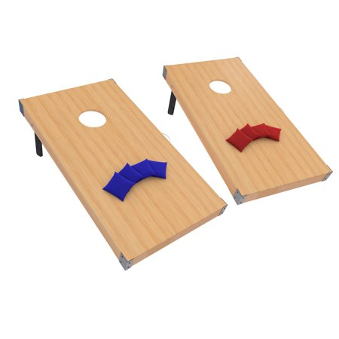
$2.00 - adults

